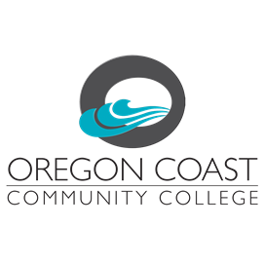

SPARE – Instructional Programs
(Service and Program Annual Review and Evaluation)

Program Name:
Update/Review Year:
Instructions: SPAREs are due in August/September of the scheduled year. They consist of:
- a look back and evaluation of assessment outcomes and goals/objectives for the prior academic year
- planning for the current academic year (year of report submission)
- funding requests for the next fiscal year, subsequent to the reporting year.

Student Learning Outcomes Assessment

- List your program/discipline outcomes below, with the aggregated student achievement levels

- In the last year, how has assessment of course level SLOs led to improvements in student learning and achievement?

- In the last year, how has assessment of program-level SLOs led to improvements in student achievement and completion?

- What challenges remain to make course and program level Student Learning Outcome Assessment more effective for your program?

Update on Program/Discipline Goals and Objectives:
- Provide an update below on your program/discipline’s progress toward achievement of short-term objectives you established in your previous review/annual update. Are there challenges that have been encountered in accomplishing your objectives?
List your department goals and objectives.

What did you accomplish toward the achievement of these goals in the prior year?

- As you look forward to this current academic year, identify two or more short-term objectives below that will continue to promote progress toward the institution’s mission of achieving equitable outcomes for students at the College? Where are the largest equity gaps in your program/discipline? Which groups are most impacted? Where in the educational pathway are the largest gaps (enrollment, retention/drop rates, success, transfer)?

Short-term Equity and Inclusion Objectives for the current academic year:

- As you look to the next fiscal year (subsequent to this reporting year), identify two or more short-term objectives below that will continue to promote progress toward your program/discipline’s achievement of your long-term goals.

Requests for Resources for the Next Fiscal Year (Subsequent to Reporting Year)

- For any specific aspect of a goal or objective listed above that would require additional financial resources, complete the form below. If you are aware of a potential funding source other than college general funds, identify the potential source below.

Type of Resource | Requested Amount | Potential Funding Source

- Describe the purpose of the resource request.

- How does this request further college fulfillment of the college mission and its Core Theme objectives?

