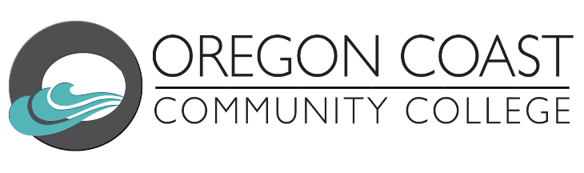

Medical Assistant Application Process
*The Medical Assistant program is a limited entry program. The application typically opens in May and is offered every Fall term. The course may be cancelled for low enrollment or other factors such as faculty availability.

Checklist | Description
Review Medical Assistant Web Page | Medical Assistant - Oregon Coast Community College
Apply to OCCC | After receiving the welcome email from our college, follow the instructions to set up your college email and student accounts.
Book Advising Appointment + Attend an Academic Orientation | Advising - Oregon Coast Community College  The advisor for nursing & allied health can assist with general advising, orientation sign up and answer other questions.
Know Your Payment Plan | If you plan on using financial aid, be sure to complete the FAFSA application and list our school. After you have completed your FAFSA, you will also need to complete a budget.
Medical Assistant Application | The MA application will be posted on the medical assistant web page for each term that it is being offered.
Registration | Once all steps are completed, you may register.

